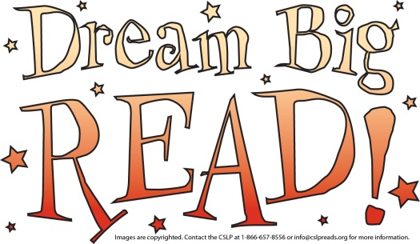

**Stratford Public Library Summer Reading 2012**

**Friday nights at 6:30 pm**

**Dates: June 8th & 22nd, July 6th & 27th**

**Grand Finale August 10th**

To register you can stop in, call, fax, or email your age and grade to us By June 6th, 2012

**816 Shakespeare Ave**

**Stratford, IA 50249**

**Phone: (515)838-2131 Fax: (515) 838-2183**

**Email:stratlib@globalccs.net**

[**http://www1.youseemore.com/nilc/Stratford/**](http://www1.youseemore.com/nilc/Stratford/)

